Soldier, Soldier
“A kind gesture can reach a wound that only compassion can heal.”
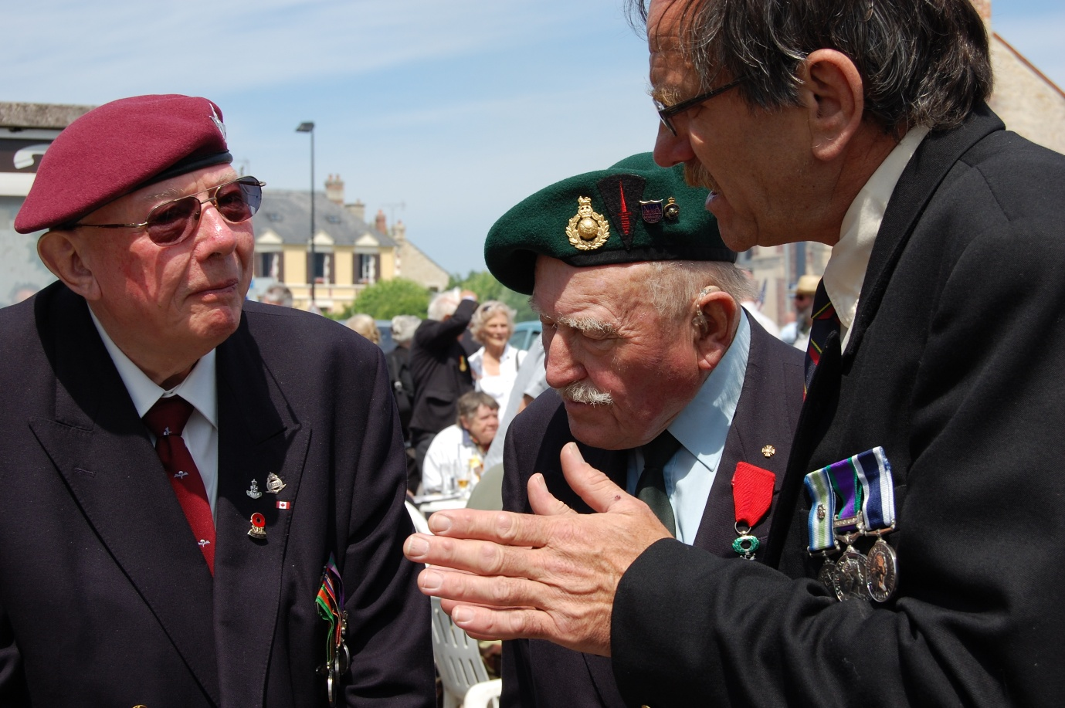
Written by David Jackson/Chris Reeves
Vocals: David, Piano: Leo and Mal.
Soldier Soldier came to me as a gift from an old friend who had very little to give except honesty and gratitude. He wrote it about me, and I’ve always kept that clear. Its origins belong to Chris, and to the moment he handed it over.
Over the years I shaped the song to fit my own journey, adding a fourth verse and small changes that brought my veteran story into its heart. I’ve performed it in both blues-rock and acoustic styles, each carrying its own weight. Each time I’ve played it, the song has revealed something different, as if it’s grown alongside me.
This acoustic version is the first to be released, with the blues-rock version appearing on my next album, The Unravelling of What Was Lived.

Soldier, Soldier

Soldier, soldier, handsome and brave
You've got the world to save, do you really feel the pain
Soldier, soldier I've tried all I can
Are you the answer, will you finally make me a man?

I'm tired of dreams that just get bigger
I want to feel my finger on the trigger
My reality's been torn apart
And you say you pay good money if you numb your heart

Soldier, soldier, can I learn that lifestyle too
Strong and distant, invincible and true
You pull the trigger, but it's not really you
Get drunk in a graveyard, so you wanna be hard man too

I'm tired of dreams that just get bigger
I want to feel my finger on the trigger
my reality's been torn apart
and you say you pay good money if you numb your heart

Soldier, soldier can I look inside your mind
It's the glamour and glory and the girls you've left behind
You tell the story of a hero in the night
He'd never run away but he always wins his fights

I'm tired of dreams that just get bigger
I want to feel my finger on the trigger
my reality's been torn apart
and you say you pay good money if you numb your heart

Soldier, soldier you just don't fall in line
All the booze and the drugs that make you lose your mind
Standing by the graveside of a hero in the night
Who's lost forever and the demons you still fight

